**AWS CLI:**

We are able to access AWS Cloud from Web console

AWS CLI

AWS Cloud

Web console (GUI)

Terraform

AWS SDK

For DevOps Engineer, which option is trending in industry, it is Terraform

AWS CLI: Command-line interface

Ways for infrastructure configuration: AWS management web console, AWS CLI (Command-Line Interface)

AWS CLI ---> Usually the script provides you with flexibility to manage AWS resources and infrastructure

We need an AccessKey and SecretKey

Go to : <https://docs.aws.amazon.com/cli/latest/userguide/getting-started-install.html>

Click on this link:

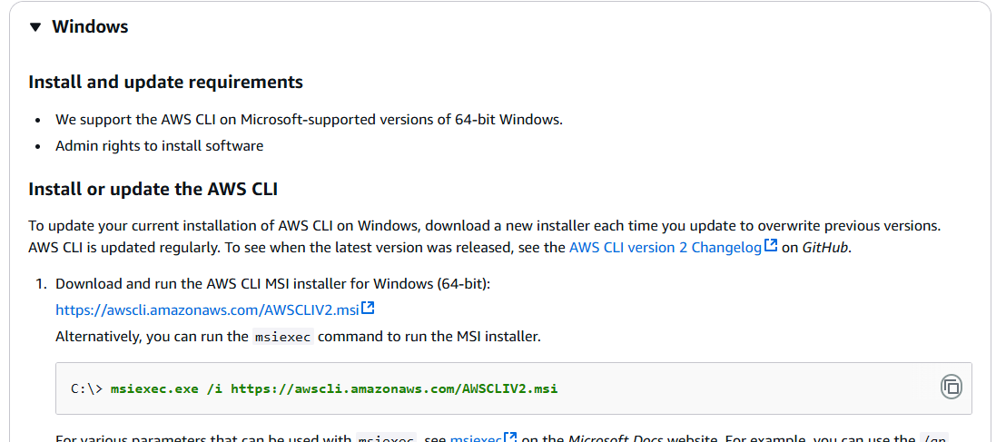

Install AWS CLI on Windows

msiexec.exe /i <https://awscli.amazonaws.com/AWSCLIV2.msi>

Or click on [https://awscli.amazonaws.com/AWSCLIV2.msi](https://awscli.amazonaws.com/AWSCLIV2.msi" \t "https://docs.aws.amazon.com/cli/latest/userguide/_blank)

Install AWS CLI

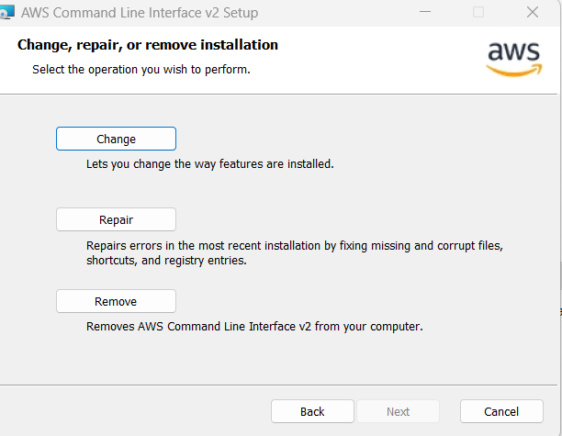

Go to AWS Console ---> Security credentials

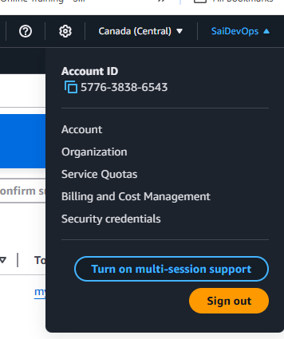

Create access key --> What’s recommended is. Create an IAM user first then create access key for that IAM user

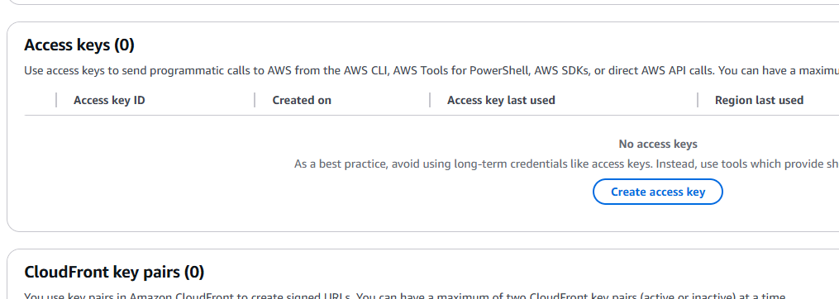

I will delete access key right after using it

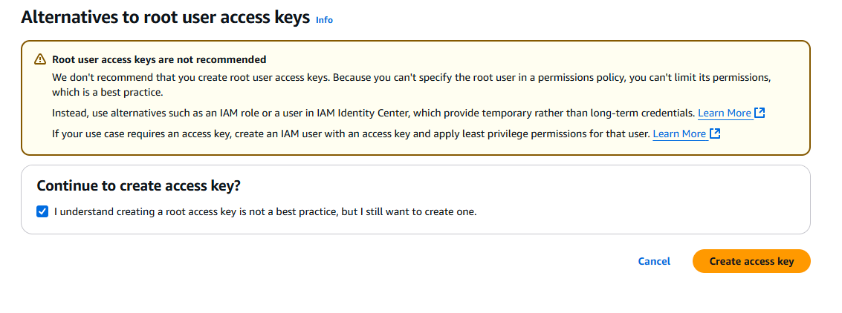

Configuring AWS CLI

1. Create an AWS account in order to configure AWS CLI (Use existing if you already have one)
2. Create IAM user with Security credentials (Access key and Secret key)
3. Open Command prompt and connect

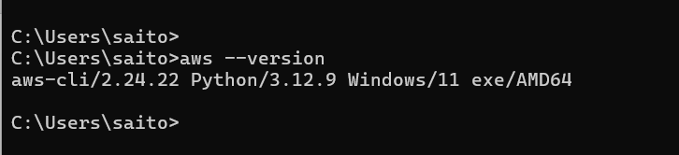

Next type --> aws configure

Enter AWS Access key and secret key

Correct the region to ca-central-1

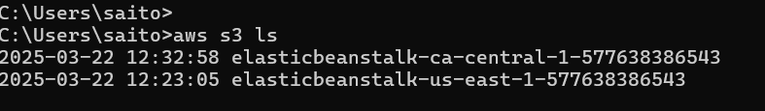

Go to AWS CLI Command Reference

<https://docs.aws.amazon.com/cli/latest/>

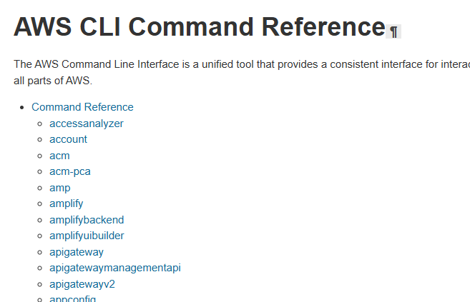

CLI Documentation: <https://docs.aws.amazon.com/cli/latest/>

Example for EC2: <https://docs.aws.amazon.com/cli/latest/reference/ec2/>

Example to attach volume to EC2

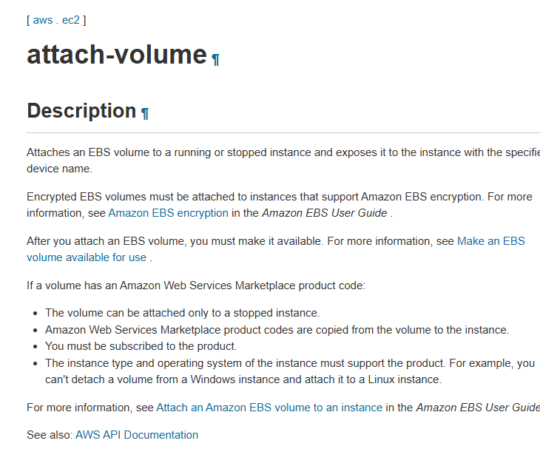

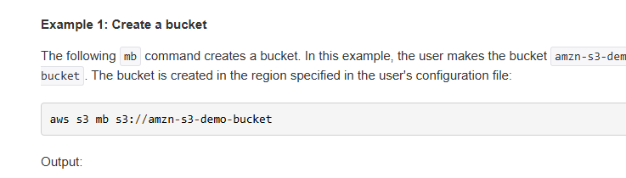

Create a new bucket

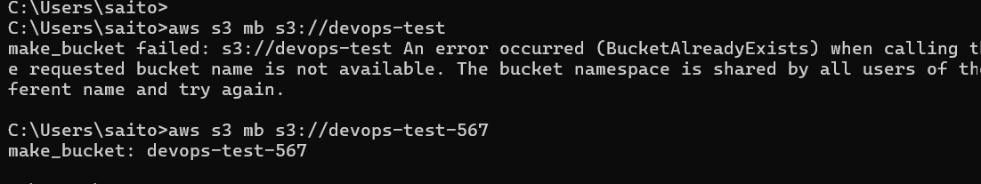

One more bucket is there

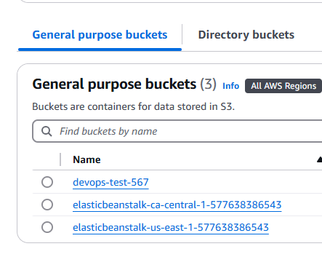

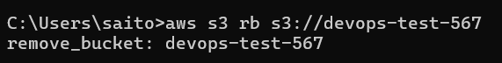

For every action we need to use commands and which command to run those details are available in AWS documentation

For example:

To Display bucket list: aws s3 ls

Create a new bucket: aws mb s3://<new_bucket>

Delete an empty bucket: aws rb s3://<bucket_name>

